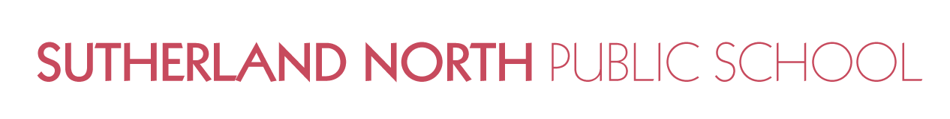

Dear Parents & Carers
A feature of the public education system in NSW is the opportunity to provide time in class for education in ethics, faith and morality from a religious or non-religious perspective at the choice of parents.
The school website www.sutherlann-p.schools.nsw.edu.au provides information on these options to support parent/carer choice.
A parent/carer may at any time notify the school in writing that they wish to change their decision. Students will continue the same arrangement as the previous year, unless a parent/carer has requested a change in writing.
For more information about Special Religious Education (SRE) and Special Education in Ethics (SEE), including the list of approved providers, please visit: https://education.nsw.gov.au/teaching-and-learning/curriculum/learning-across-the-curriculum/religion-and-ethics
If your preferred SRE or SEE option is not available please contact the approved provider. Students not attending SRE or SEE are given supervised alternative meaningful activities.
The following options are available at Sutherland North Public School. Please choose one.
SRE Options
□ Option 1: Catholic (Years K-6)
□ Option 2: Protestant (Anglican, Uniting, Presbyterian, Baptist etc) (Years K-6)
OR
□ Please check this box if you DO NOT wish for your child to attend SRE or SEE. Your child will participate in alternative meaningful activities.

Student name: _______________________________________ Year: ____________
Signature of parent/carer: ______________________________ Date: ____________

Fiona Young
Principal

